Olzhas Kurikov

[ok34@hw.ac.uk](mailto:ok34@hw.ac.uk)

**Resonant Ultrasound Spectroscopy**

Analysis of thickness resonances to characterise a material

Master Thesis Project

16.01.2017 – 03.07.2017

Supervisor

Prof. Marc Desmulliez

Second supervisor

Prof. Thomas Speck

Co-supervisor

Dr. Anne Bernassau

Heriot-Watt University, Edinburgh

Albert-Ludwig’s University, Freiburg

1. **Introduction**

The aim of this project was to establish reliable setup to characterise a living material using resonant ultrasound spectroscopy. In the first stage of the project, the solid materials such as aluminium, glass and plastics were tested to prove that setup is well tested and ready to switch to a living materials such as plants. The experiments were performed with aluminium, glass and plastic due to existing elastic constants, hence it is straightforward to compare datasheet values to analysed data.

The main reason why exactly ultrasound resonant spectroscopy was used is that that by measuring transmission coefficient of a sample, RUS can infer parameters like thickness, density, attenuation coefficient, speed of sound and first order resonant frequency. Moreover, this technique is non-destructive, non-invasive, rapid and relatively inexpensive. Therefore, there is no damage on a sample which is significantly important for a plant samples, while running the experiment.

Coefficient of transmission of sound at normal incidence through each sample in the frequency range 0.6 MHz – 1.7 MHz was measured. For all cases, at least one thickness resonance was observed. From these measurements density, sound velocity, and attenuation of ultrasonic longitudinal waves were obtained and compared to available data provided in an articles or by manufacturers.

The method is based on frequency-domain analysis, by using the Fast Fourier transform, of pulse transmitted through a sample.

All the experiments were conducted in Biology department of Albert-Ludwig’s University of Freiburg city in Germany. And the required equipment, except oscilloscope (listed below) were transported from Heriot-Watt University, Edinburgh:

* Transducer
* Hydrophone
* Water tank
* Pulser/receiver
* DC coupler
* Oscilloscope

Results reveal that these resonances are strongly sensitive on different parameter changes which are discussed further in the report.

This report goes through all the steps and problems which are faced during the experiments and gives suggestions for further improvements.

All the needed information such as analysed data, Matlab and Python codes, setup instruction, the report can be provided via GitHub control system.

1. **Literature review and theory**
   1. **Fundamentals of ultrasound**

**2.1.1. Ultrasound**

The sound waves with frequencies above 20 kHz is called ultrasound and they are not in range for human hearing (William, 2012). Ultrasound is broadly used technique in different applications of medicine, food industry, factories and non-destructive testing. Sending and receiving of transmitted or reflected ultrasonic pulses allows ultrasonic devices to detect objects, defects and measure distances.

Ultrasound imaging (sonography) is mostly used in medicine to identify a health or gender of baby. In the non-destructive testing of materials or structures, ultrasonic waves are used to detect flaws. Industrially, ultrasound is used for cleaning, mixing and to accelerate chemical processes. In living environment, animals like bat and porpoises use ultrasound to locate prey and obstacles.

**Table I.** Frequency classification of Ultrasound

|  |
| --- |
| Frequency (Hz) Classification |
| 20 – 20.000 Audible sound  20.000 – 1.000.000 Ultrasound  1.000.000 – 30.000.000 Diagnostic ultrasound |

**2.1.2. Ultrasonic waves**

In ultrasound, high-frequency sound waves travel through the material being tested and information about parameters of a material are then obtained by measuring the type and interaction angle between the sound wave and the testing sample. When the sound waves are introduced within a sample, alternating molecular compression and rarefaction takes place. There are 2 modes of waves which propagates through a solid material:

* Longitudinal waves (pressure waves)
* Transverse waves (shear waves)

Longitudinal waves, where oscillation happens in the same direction as the wave is moving. This type of wave can be generated in liquids, solids and gases. In transverse wave, the oscillation occurs perpendicular to the direction that the wave is travelling in. This type of wave is propagated in solid structures only. Figure 1 represents these types of waves.

**Figure 1.** Longitudinal and transverse waves (http://www.keywordsuggests.com/)

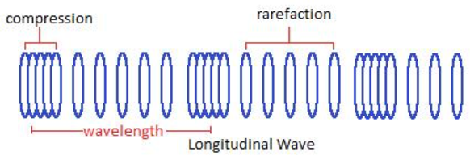 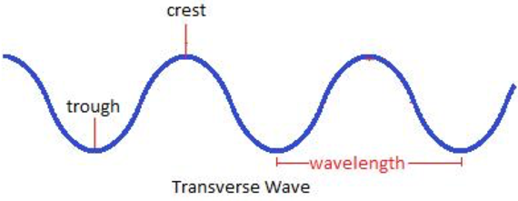

**Wave characteristics**

An area of compression and a neighbouring zone of rarefaction identify one cycle of an ultrasound wave. A wave cycle can be depicted as a graph of local pressure in the medium versus distance I along the direction of the wave (Figure 2). The wavelength is the distance covered by one cycle. The number of cycles per unit time introduced in the medium each second is referred to as the frequency, and measured in unit of hertz, kilohertz or megahertz, where 1 Hz is 1 cycle per second. The maximum height of the wave cycle is referred to amplitude of the ultrasound wave. And the multiplication of the frequency ($v$) and the wavelength (λ) is the velocity of the wave and expressed as below (William, 2012):

$c=vλ$ (1)

**Figure 2.** Characteristics of an ultrasound wave

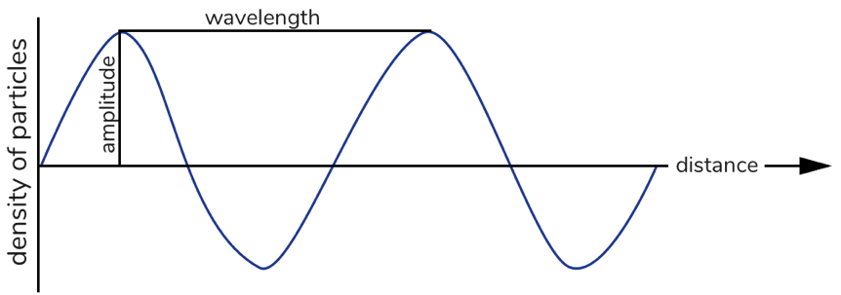

**Interaction of waves**

Interference of waves occurs when to waves meet. There are two extremes of waves’ interference: constructive and destructive. In constructive interference peak meets with other peak, they are said to “in phase” and in destructive interference the waves are “out of phase”, hence two waves cancel each other out. Waves experience constructive interference when their amplitudes added, whereas waves undergoing destructive interference can completely nullify each other (Figure 3).

**Figure 3.** Interference of two waves

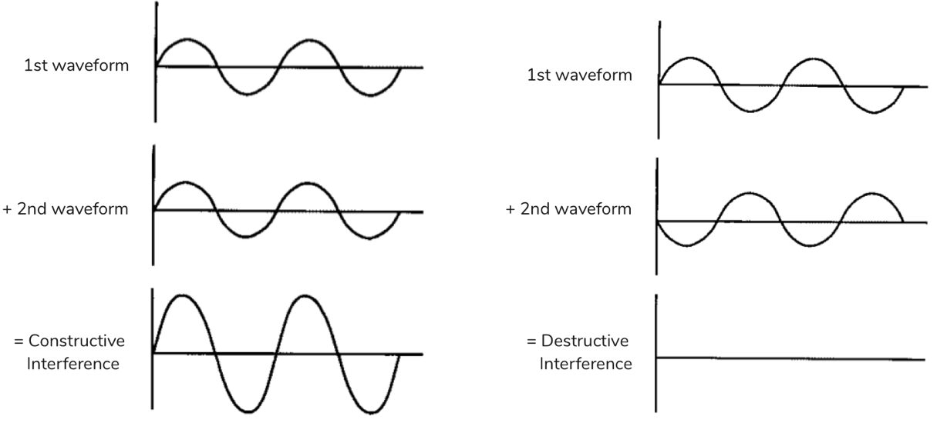

**Reflection and Transmission**

The part of incident energy reflected from the surface directly depends on the different in acoustic impedance of the material on opposite sides of the interface. The acoustic impedance can be expressed as follows:

$Z= ρc= \frac{ωρ}{k}$ (X)

where Z is acoustic impedance of medium, $ρ$ is density of the medium and $c$ is the speed of sound in the medium, $ω$ is angular frequency and $k$ is wavenumber (explained below).

In a case of one layer material the reflection coefficient $α_{R}$ is shown below (ultrasound wave incident perpendicular):

$α_{R}={(\frac{Z_{2}-Z_{1}}{Z_{2}+Z_{1}})}^{2}$ (X)

where Z1 and Z2 are the acoustic impedances of two different media. The fraction of the incident energy is transmitted through the media and can be described by transmission coefficient:

$α_{T}=\frac{4Z_{1}Z_{2}}{{\left(Z_{1}+Z_{2}\right)}^{2}}$ (X)

Therefore, it is clear, that:

${ α}_{R}+α_{T}=1$ (X)

A large impedance mismatch occurs at an interface, when the most of energy if reflected, and only small portion is transmitted across the interface. For instance, ultrasound energy is significantly reflected at air-

tissue and air-water interfaces, because the air impedance is much less than tissue or water.

**Refraction**

The direction of incident beam is changed once it crosses an interface obliquely between two media. If the velocity of ultrasound is higher in a second medium, then the beam enters this medium at less steep angle. This behaviour of ultrasound beam is called refraction. The relationship between incident angle and refracted angle can be described by Snell’s law:

$$\frac{sine of incident angle}{sine of refractive angle}= \frac{velocity in incidence medium}{velocity in refractive medium}$$

$\frac{{sinθ}_{i}}{{sinθ}_{r}}= \frac{c_{i}}{c_{r}}$ (X)

**Figure 4.** Reflection, refraction and transmission of ultrasound

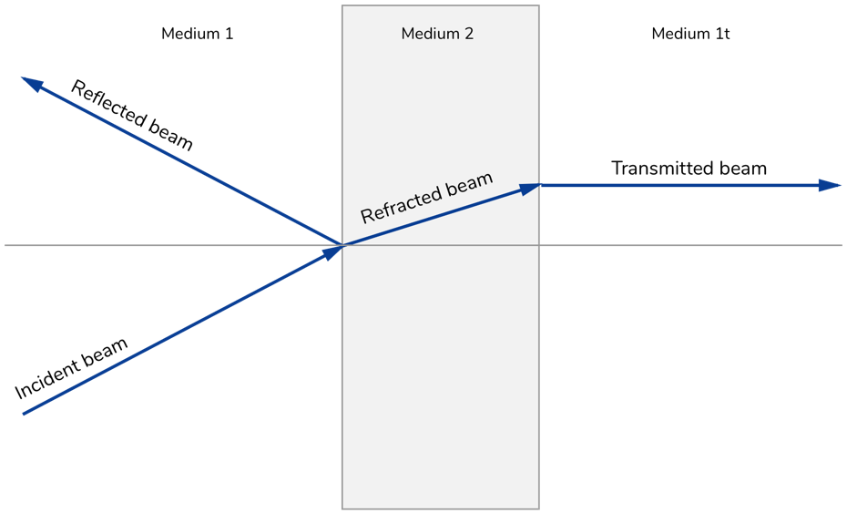

**Note to Figure 4:** The beam hits the medium 2 at an angle of $θ_{i}$. A portion of the energy is reflected at an angle of $θ_{r}$ and part of energy goes through at an angle of $θ_{ref}$.

**2.1.3. Ultrasound intensity**

As an ultrasonic waves pass through a medium, it transfers energy through the medium. The amount of energy transport is called “power”.

The rate of flow of energy (power) per unit of cross sectional area is called intensity. Intensity is commonly described relatively to another intensity; for example, the intensity of ultrasonic waves transmitted through medium may be compared with that of the ultrasound sent into the material. The intensity is measured in a logarithmic scale, since it is the most appropriate for recording data over a range of many orders of magnitude. The decibel scale is used in acoustics:

$dB=10log\frac{I}{I_{0}}$ (X)

where $I_{0}$ is the reference intensity. Due to intensity is power per unit area and power is energy per unit time, it is possible to write above expression as:

$dB=10log\frac{Power}{{Power}_{0}}=10log\frac{E}{E_{0}}$ (X)

Ultrasound wave intensity is allied to maximum pressure ($P_{m}$) in the medium by the following expression:

$1= \frac{P_{m}^{2}}{2ρc}$ (X)

where $ρ$ is the density of the medium and $c$ is the speed of sound in the medium. When we substitute Eq. (X) for $I$ and $I_{0}$ in Eq. (X):

$dB=10log\frac{P_{m}^{2}/2ρc}{{{(P}_{m}^{2})}_{0}/2ρc}=10log\left[\frac{P_{m}}{P_{m0}}\right]=20log\frac{P_{m}}{P_{m0}}$ (X)

While comparing two pressure waves, Eq. (X) can be used directly; the pressure does not have to be converted into intensity to find dB value.

**2.1.4. Ultrasound velocity**

The speed of an ultrasonic wave through a medium changes and it depends on the physical properties of the medium. The velocity of an ultrasonic wave is relatively low in low-density media such as air and gases, since the molecules in them move over relatively large distances before they impact neighbouring molecules. In solids, the molecules are limited in their motion, and the ultrasound velocity is relatively high. In

another hand, liquids demonstrate ultrasound velocities in-between those, gases and solids.

**Table II.** Approximate velocities in different medium

|  |  |
| --- | --- |
| Nonbiological material Velocity (m/s) | Biological material Velocity (m/s) |
| Aluminium 6400  Plastic 2680  Water (degassed) 1480  Glass 5640  Air 330 |  |

**2.1.5. Ultrasound attenuation**

As an ultrasound beam penetrates a medium, energy decreases due to absorption, reflection and scattering, so to say, the attenuation of ultrasound is when sound intensity decreases exponentially with distance from the source.

Donation to attenuation of an ultrasound beam can include:

* Reflection
* Absorption
* Scattering
* Refraction
* Diffraction
* Interference

Ultrasound energy is absorbed by a medium when the fraction of the beam’s energy turned into other forms energy, like an increase in the arbitrary motion of molecules. Ultrasound is reflected back when the angle of reflection is same as incident angle. If the part of beam changes direction in a less orderly manner, this phenomenon is called “scattering”.

The attenuation of ultrasound in a medium is expressed by attenuation coefficient α in units of dB/cm or Nepers per meter(1 Np = 8.686 dB). The attenuation coefficient is the total amount of individual coefficients for scattering and absorption and can be expressed as follows:

$A= A_{0}e^{-αx}$ (X)

where α is attenuation coefficient, A is amplitude of the ultrasound wave, A0 is the initial amplitude and $x$ is the distance the wave has travelled through the medium. (McClements and Gunasekaran, 1997)

**Table III.** Attenuation coefficient $α$ for 1 MHz ultrasound

|  |
| --- |
| Medium α (dB/cm) |
| Blood 0.18  Fat 0.16  Muscle 3.3  Water 0.0022  Bone 20  Brain 0.85 |

**Note to Table III:** The given figures in table are relative and may vary with both the origin and condition of the biological sample.

* 1. **Ultrasound transducers**
     1. **Introduction to transducers**

A transducer is certain device that transforms one form of energy into another. And ultrasound transducer converts electrical energy into ultrasound energy and in reverse way. Transducer for ultrasound consists of piezoelectric crystals or elements such as quartz (silica).

* + 1. **Piezoelectric effect**

A piezoelectric effect is exhibited whenever a pressure is applied, develop voltage across opposite surfaces. This effect is used to produce ultrasound incident wave when electrical signal is applied to the transducer. Application of the voltage across the crystal causes its deformation – expansion or compression depending upon voltage polarity.

A definition of transducer is known as a fraction of applied energy that is converted into wanted energy mode. For ultrasound transducer, this definition described with electromechanical coupling coefficient; it varies whether electrical or mechanical energy is applied:

$$k_{c}^{2}=\frac{Mechanical energy is converted into electrical}{Applied mechanical energy}$$

If electrical energy is applied:

$$k_{c}^{2}=\frac{Electrical energy is converted into mechanical}{Applied electrical energy}$$

Some $k_{c}$ values for transducers are listed below in Table IV

**Table IV.** Properties of piezoelectric crystals

|  |
| --- |
| Materials Electromechanical coupling coefficient ($k_{c}$) |
| Quartz 0.11  Rochelle salt 0.78  Barium titanate 0.30  Lead zicronate titanate (PZT-4) 0.70  Lead zicronate titanate (PZT-5) 0.70 |

* + 1. **Transducer design**

The piezoelectric crystal is essential part of any transducer. A crystal generates its greatest response at resonant frequency. The resonance frequency of ultrasound transducer depends on the thickness of crystal. As the crystal goes through one

complete cycle form shrinking to expansion to the next shrinking, compression waves move in direction of centre of the crystal form opposite side of its face. It is complicated to “drive” crystal with one wavelength thickness due to the compression waves arrive at opposite surfaces just as the next shrinking starts, hence the energy is wasted. However, if the thickness of crystal is equal to half of wavelength, a compression waves happens at the crystal interface just as expansion begins to occur. A crystal with half wavelength resonates at a frequency:

$f=\frac{c}{λ}=\frac{c}{2t}$ (x)

The plastic sealing of crystal has a thickness of ¼ $λ$ and it is called quarter-wavelength matching layer.

**3.2. Results and discussion**

As stated in introduction section, the purpose of project was to establish reliable setup to have reproducible and repeatable data. The experimental setup is straightforward and data analysis process is fast and simple. However, since there is large amount of parameters there were certain issues regarding the equipment and the data analysis process. They were tested accordingly in order to investigate how the changes of different parameters can influence on data results. All the measurements were performed with solid materials, mostly aluminium sample. The reason behind of experimenting on solid materials is it is simple to compare the retrieved results with literature values or data sheet. That proves that the setup and technique is functioning in correct way and data is reproducible before moving into biological species. The subsections below will show how the results change according to variation of parameters.

**3.2.1 Measurements with samples on default settings**

Before understanding the variation of parameters, the default settings for pulser/receiver and oscilloscope (Frederike, 2016) were used to obtain and compare the results afterwards. The experiments were conducted only on the samples which were available at that time with different thicknesses to see the results and continue ….. Default settings are depicted in a Table X below:

**Table X.** Settings for pulser/receiver and oscilloscope by default

|  |  |
| --- | --- |
| Pulser/receiver | Oscilloscope |
| Relative gain 38 dB  High pass filter out  Low pass filter 35 dB  Pulse repetition frequency: 1 (100Hz)  Pulse amplitude 11  Trigger Internal (INT)  Pulse energy High 3  Damping 2 | Amplitude 5 V/division  Time 2μs/division  Delay 72.56 μs |

All the lines represented in pictures:

* Red line on the graphs is measured data without sample
* Yellow line on the graphs is measured data with sample
* Blue line on the graphs is the difference between measured data with sample and without sample
* Section with bold blue line on magnitude graphs is the measured data which is process in python

**Experiment 1. Glass with 2 mm thickness**

**Figure X1.**  Detail in the phase and magnitude spectrum of the first received pulse without and with sample between transducer and hydrophone. The graph shows MATLAB output

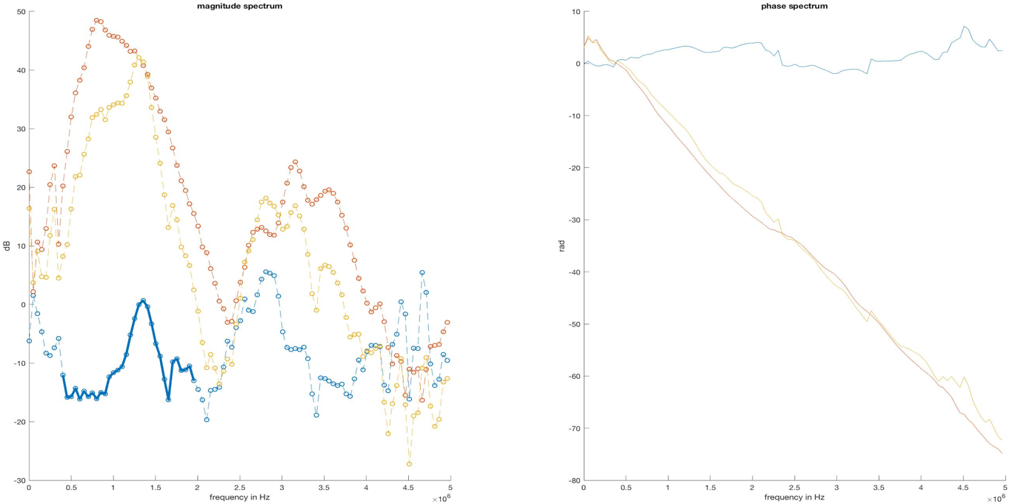

**Figure X2.**  Transmission coefficient spectra with fitted theoretical transmission coefficient of a measured glass sample.

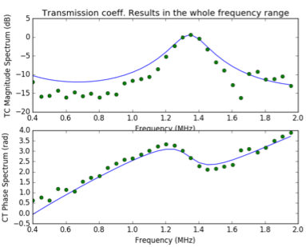

**Table X1.** The results obtained from python algorithm compared with calculated and/or literature data for further investigation on the issues of setup and/or data analysis.

|  |  |
| --- | --- |
| Parameters Python output | Calculated and/or literature data |
| Thickness (mm 0.98  Velocity (m/s) 2726  Density (kg/m3) 4293  Resonant frequency (MHz) 1.35 | 1.92  4540  2719  1.18 |

**Experiment 2. Glass with 3 mm thickness**

**Figure X2.** Detail in the phase and magnitude spectrum of the first received pulse without and with sample between transducer and hydrophone. The graph shows MATLAB output

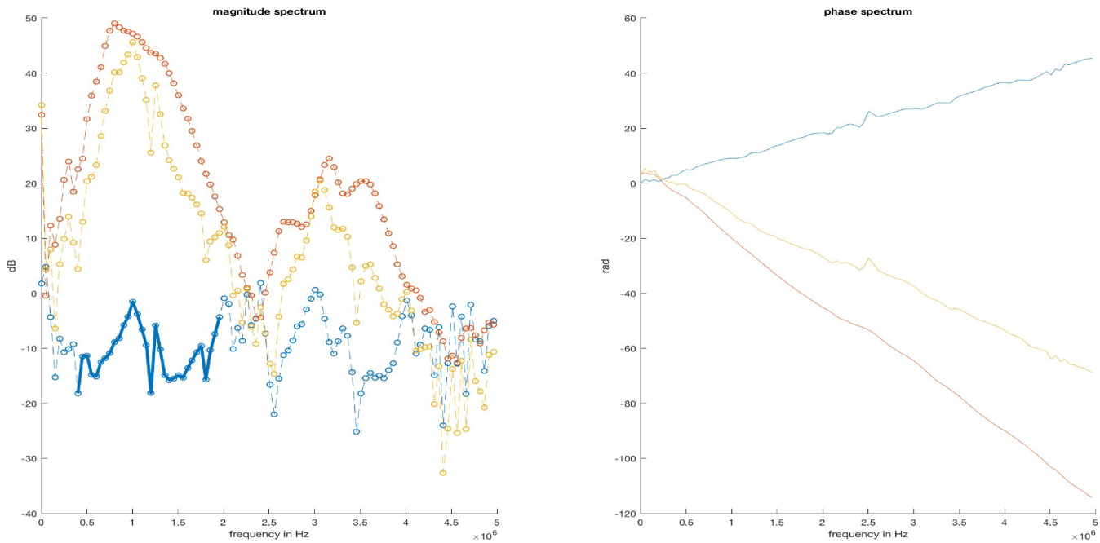

**Figure X3.**  Transmission coefficient spectra with fitted theoretical transmission coefficient of a measured glass sample.

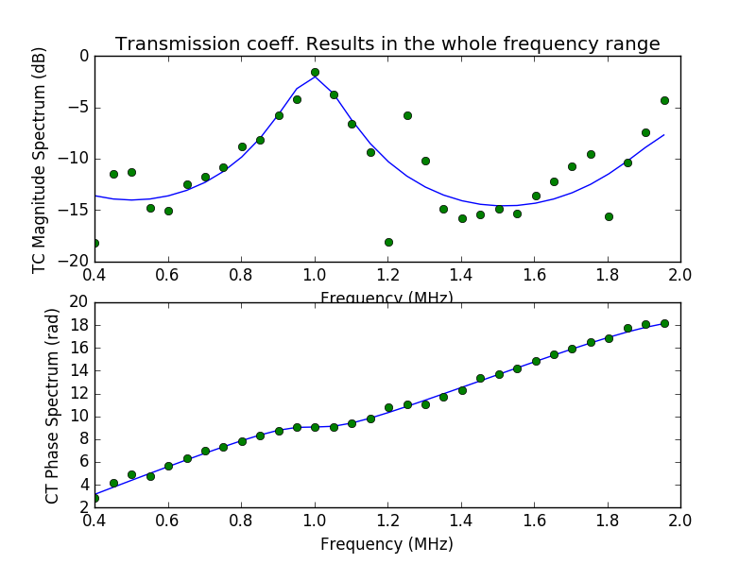

**Table X2.** The results obtained from python algorithm compared with calculated and/or literature data for further investigation on the issues of setup and/or data analysis.

|  |  |
| --- | --- |
| Parameters Python output | Calculated and/or literature data |
| Thickness (mm 2.80  Velocity (m/s) 5662  Density (kg/m3) 2596  Resonant frequency (MHz) 1.00 | 2.72  4540  2683  0.84 |

**Experiment 3. Aluminium with 3 mm thickness**

**Figure X5.**  Detail in the phase and magnitude spectrum of the first received pulse without and with sample between transducer and hydrophone. The graph shows MATLAB output

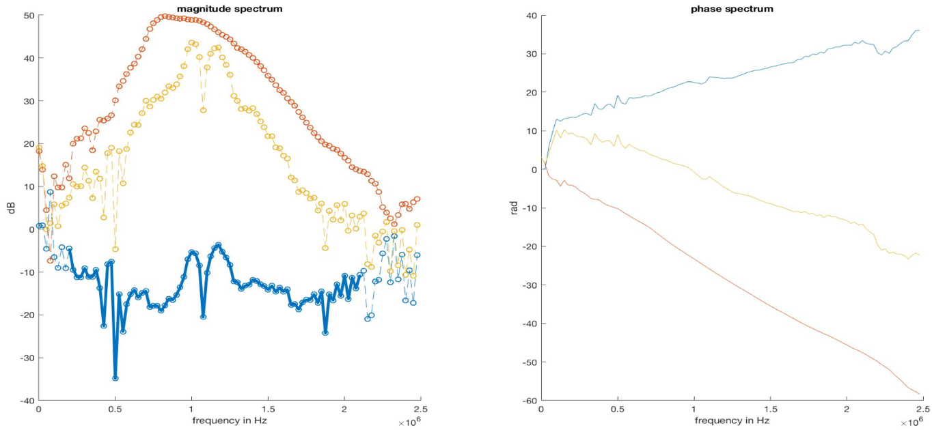

**Figure X6.**  Transmission coefficient spectra with fitted theoretical transmission coefficient of a measured glass sample.

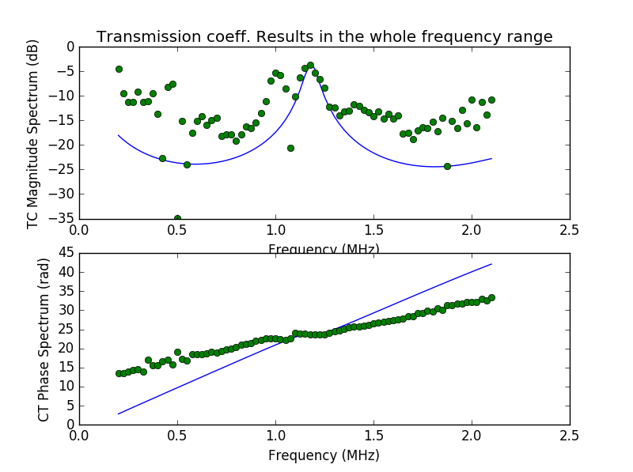

**Table X3.** The results obtained from python algorithm compared with calculated and/or literature data for further investigation on the issues of setup and/or data analysis.

|  |  |
| --- | --- |
| Parameters Python output | Calculated and/or literature data |
| Thickness (mm 5.10  Velocity (m/s) 12186  Density (kg/m3) 3677  Resonant frequency (MHz) 1.17 | 2.76  6400  2830  1.16 |

As it can be seen from results above, the measured data curve did not fit nicely with theoretical curve as well as the python output values with calculated values. However, whole data process showed acceptable correct resonant frequencies. First experiments with affordable samples gave a common understanding emerged on the need for further research with aluminium samples with different thicknesses which were manufactured in workshop later. Further in this section the focus was on improving this results in varying degrees. The first assumption was to guarantee that the equipment, specifically pulser/receiver is working as intended, since the pulser/receiver amplifies and enhance signal-to-noise to produce clear signal on the scope.

**3.2.2. Characterisation of pulser/receiver**

The figure below depicts a front panel of pulser/receiver and shows all-wheel control button which are available on it.

**Figure X.**  The front panel of pulser/receiver indicating all the available switches on it. These toggles can be easily changed for better signal representation.

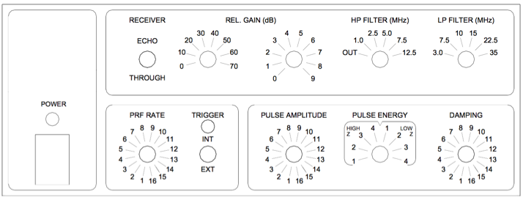

A common analytical and experimental challenges were to better understand a relationship between pulser/receiver and signal representation on the scope and how the modification of parameters on pulser/receiver can reshape the pulse signal. Under the circumstances, a series of experiments were conducted where the control switches were varied, hence the optimal variant were selected for further experiments.

**Filters (High pass filter and Low pass filter)**

High pass filter (HP filter) allows to bypass all the frequencies in the range of 1 MHz and 12.5 MHz. As stated above, the provided transducer operates in bandwidth of minimum 0.49 MHz and maximum 1.61 MHz with centre frequency of 1 MHz, thus it is obvious to set HP filter to “OUT”, since it is not desirable to lose any signal of transducer’s frequency range.

Low pass filter (LP filter) permits to bypass all the frequencies which are lower than 3 MHz as minimum and 35 MHz as maximum. Therefore, LP filter plays minor importance due to the transducer bandwidth (maximum 1.61 MHz) unless to improve the signal-to-noise ratio and cut off undesirable high frequencies when a sample is introduced between transducer and hydrophone. However, the despite the theoretical understanding of function of both filters and how it should be set, they are toggled through different values to assure that they do not make much difference on the signal representation. Filters effect is described more detailed later on this section.

**Fast Fourier transformation (FFT)**

With help of direct FFT spectrum on the scope it is possible to observe the signal in frequency domain immediately. The following settings for FFT in oscilloscope were applied:

* Span: 5 MHz (it sets the overall width of the FFT spectrum that can be seen on display)
* Centre: 2.3 MHz (it sets the FFT spectrum frequency represented at the centre of vertical grid line of the display)
* Window type: hanning (by default) It selects a window to apply to the FFT settings. There are 4 types of window:
* Hanning – window to make precise frequency evaluation.
* Flat top – window to make accurate amplitude measurements of frequency peaks.
* Rectangular - good frequency resolution and amplitude accuracy. However, only can be used where there will be no leakage effects.
* Blackman Harris – window significantly lowers the resolution compared to other types, but enhances the capacity to identify smaller impulses.

**Pulse repetition frequency (PRF)**

**Experiment 1. Changes of amplitude, energy and damping at different gain values**

***Relative gain: 0 dB (minimum)***

Initially, pulse amplitude, energy and damping were switched to 1 and the signal was not visible as shown in Figure X below.

**Figure X.** Changing the parameters of pulser/receiver to see the effects on them on result. No signal observation in the display on minimum settings of switches. Pulse amplitude = 1, energy = 1, damping = 1 and relative gain = 0 dB. Yellow line – signal. Purple line – FFT spectrum.

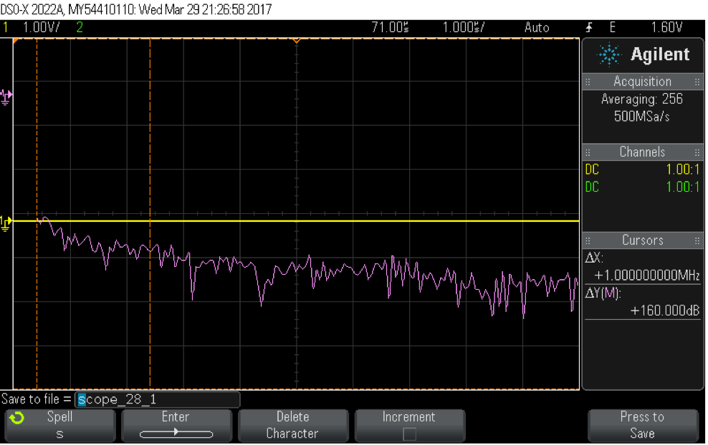

**Note:** The figures are presented only when considerable effects in signal is seen.

The minimum, medium and maximum values and their combinations of amplitude (1,8 and 16), energy (high Z 1 and 4, low Z 1 and 4) and damping (1,8 and 16) were tested.

The next step was to change energy to “high Z 4”. The actual signal is stayed unchanged, but the FFT spectrum gave response in 1 MHz. The obtained result is represented in Figure X.

**Figure X.** Changing the parameters of pulser/receiver to see the effects on them on result. Observation of FFT spectrum response on 1 MHz, but the time domain signal was still not visible. Pulse amplitude = 1, energy = high Z 4, damping = 1 and relative gain = 0 dB

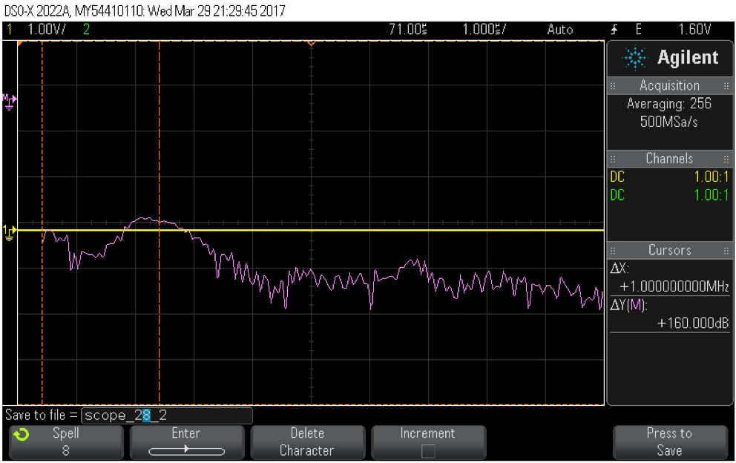

Based on same scheme, subsequent changes in parameters did not give any significant changes on the signal. After changing energy to “low Z 4” or increasing the pulse amplitude to 8 and keeping energy at “high Z 4”/”low Z 4” showed better FFT spectrum (Figure X). However, the signal was still not visible on display.

**Figure X.** Changing parameters pulser/receiver whereas the relative gain is 0 dB did not give any significant change but only in FFT spectrum. Observation of FFT spectrum response on 1 MHz, but the time domain signal was still not visible. Amplitude = 16, energy = 1 and damping = 1

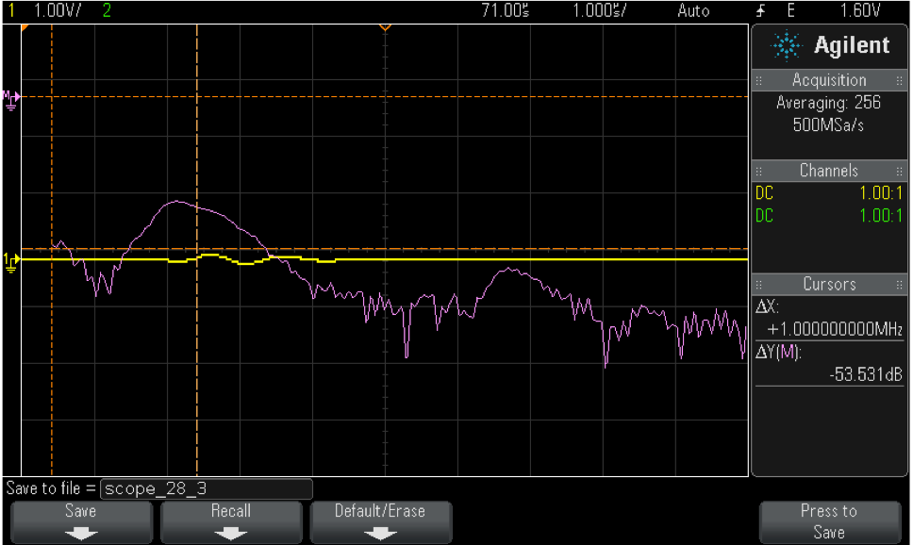

***Relative gain: 79 dB (maximum)***

This time, the relative gain was set to 79 dB to observe considerable changes in signal in all possible combinations (minimum, middle and maximum) and to ensure that 79 dB is not appropriate setting to be chosen (Figure X).

**Figure X.** The signal in time domain were displayed inadequately since some of the peaks were distorted and clipped. Pulse amplitude = 1, energy = high Z 4, damping = 1

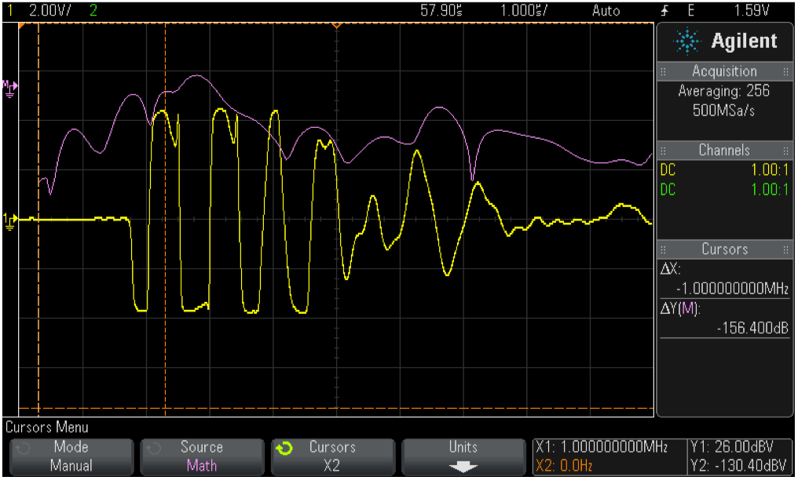

Note: several toggles were changes in pulser section to retrieve good signal representation, but a similar results as in Figure were obtained.

***Relative gain: 39 dB (middle)***

Building on above results, this time the relative gain was set to 39 dB. A remarkable change was observed and noted. Based on 39 dB, all the possible combinations for amplitude, energy and damping were attempted and the optimal variant was selected for future experiments. All the combinations’ figures are attached in Appendix in the end of this report.

Amplitude. As expected, the signal and FFT spectrum’s amplitude increases with increasing amplitude value, independently on other settings. If the amplitude is turned to 8 and energy is “low Z 4” or amplitude is 16 in all cases, then the signal is clipped and FFT spectrum changes respectively.

Pulse energy. Increasing energy from 1 to 4 (high and low) increases the amplitude of the signal. In some combinations, FFT shape changed a little, especially with “low Z” values or with maximum amplitude (16). The possible reason for that might be the clipping and distortion of the signal in time domain.

Impedance. It was observed that with “low Z” values, the amplitude is bigger than with “high Z” values. And that is in line with manual stating that “low Z” impedance provides better signal strength.

Damping. With rising damping values applied to the transducer, the signal’s amplitude was decreased. Also according to the datasheet, the “high Z” impedance values provides better damping to a transducer, hence the amplitude appears to be smaller than with values of “low Z”.

Hence, following all the above experimentations, a decision was made to select following setting for pulser/receiver:

* Relative gain: 39 dB
* Pulser amplitude: 8
* Pulser energy: low Z 4
* Damping: 16

The signal with aforementioned parameters were satisfying, because the amplitude was high enough as well as the pulse energy as it was set to low impedance (not high) so it displayed sharp signal and the maximum value (4) for impedance was chosen, so that it was expected to cover a wider range of frequencies even though this phenomenon was not visible in the oscilloscope. Likewise, the signal representation with these parameters was compared with signal look in calibration sheet of transducer (Figure X).

**Figure X.** Comparison of two signals: left is signal in calibration sheet and right is signal with chosen parameters for pulser/receiver. As it can be seen from the figures they are to certain extend identical.

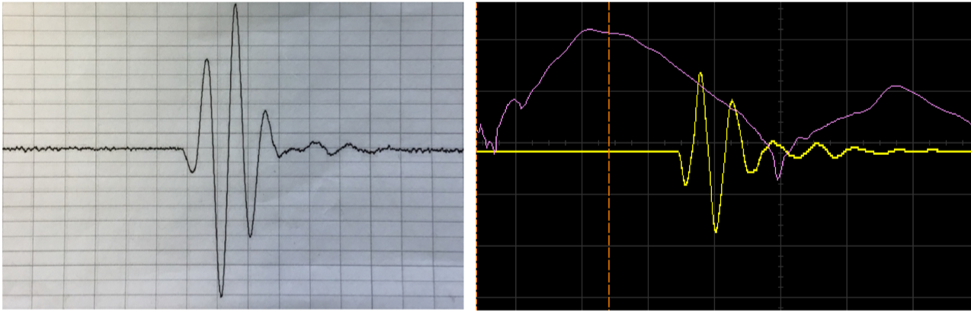

**Experiment 2. Effect of filters (HP and LP) on the settings**

Once the parameters were determined, an experiment with filters were carried out. As expected, no change in the signal was observed while changing values of LP filter. However, as a precaution, LP filter was set to 3 MHz to filter out high frequencies (noise) when a sample is inside the tank.

HP filter was experiment with 1 MHz (minimum), 2.5 MHz and 12.5 MHz (maximum) frequencies. As could be expected, the signal was distorted when frequency below 1 MHz, although the cut-off was not so strict, since there was some signal left. On other hand, increasing the HP filter value further eventually made the signal to disappear completely (Figure X).

**Figure X.** Comparison of three setting of HP filter. As it can be seen from three figures below, that with increasing value of filter the signal vanishes at maximum value.

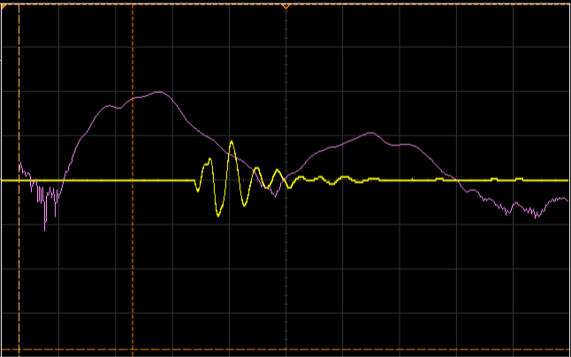 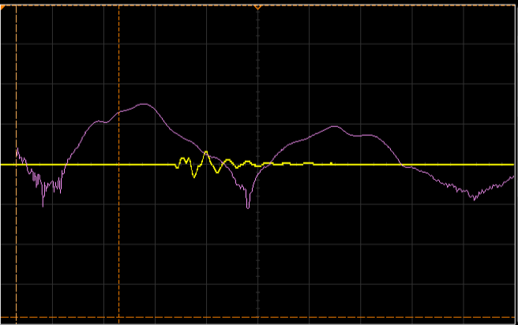

**HPF is 1 MHz HPF is 2.5 MHz**

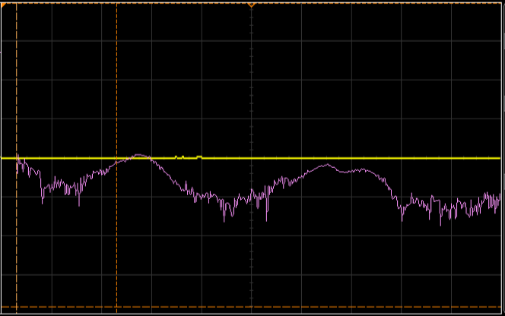

**HPF is 12.5 MHz**

To verify correct functioning of pulser/receiver with chosen parameters, a coupler was used to observe what the pusler was sending to the transducer.